[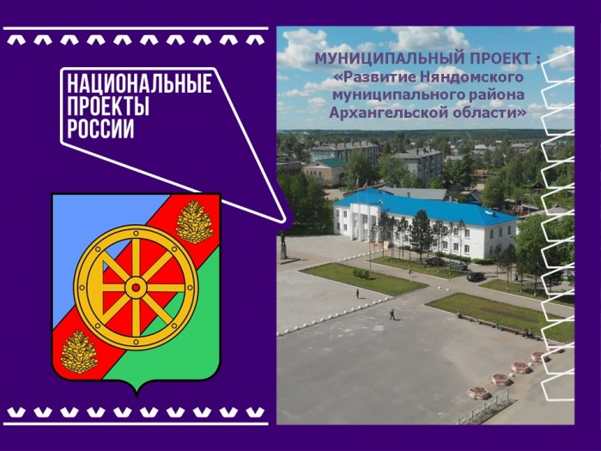](http://nyan-doma.ru/content/site_images/nyan-doma/2020/July/slayd1.jpg)[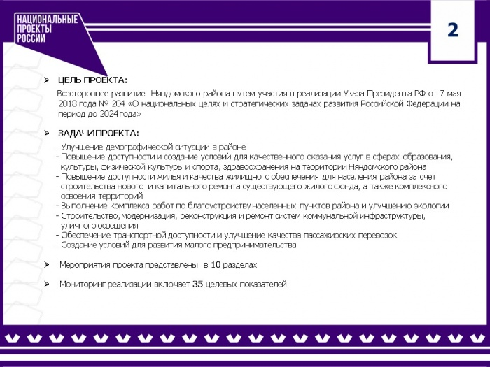](http://nyan-doma.ru/content/site_images/nyan-doma/2020/July/slayd2.jpg)[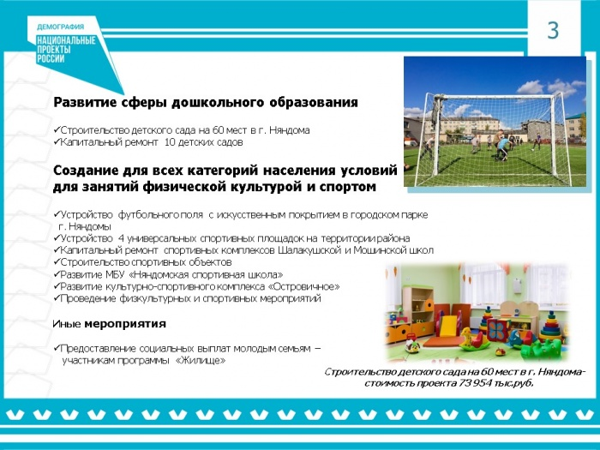](http://nyan-doma.ru/content/site_images/nyan-doma/2020/July/slayd3.jpg)[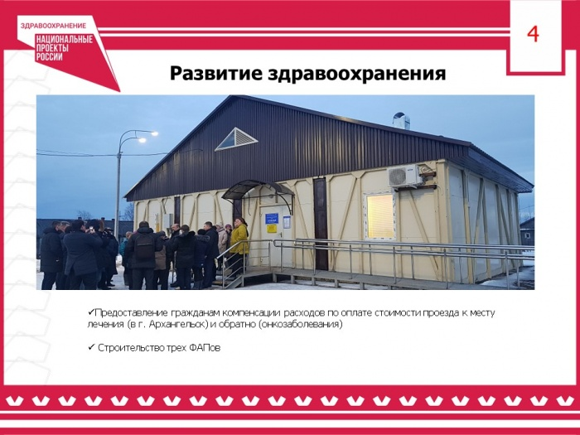](http://nyan-doma.ru/content/site_images/nyan-doma/2020/July/slayd4.jpg)[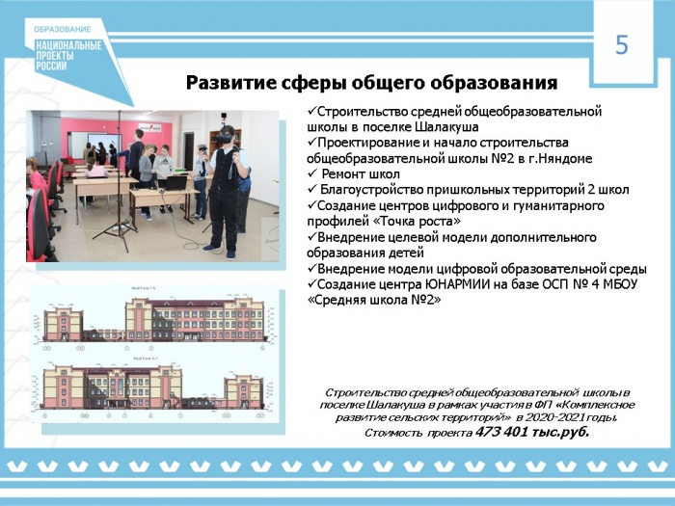](http://nyan-doma.ru/content/site_images/nyan-doma/2020/July/slayd5.jpg)[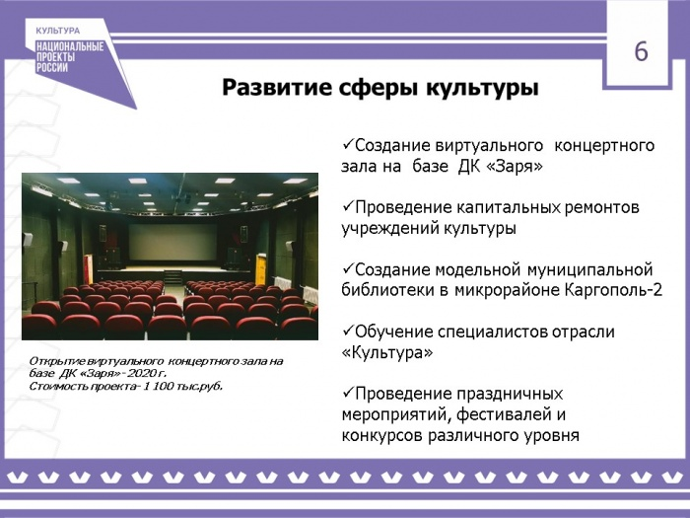](http://nyan-doma.ru/content/site_images/nyan-doma/2020/July/slayd6.jpg)[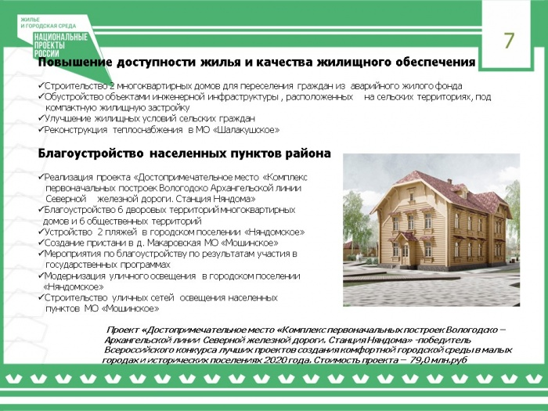](http://nyan-doma.ru/content/site_images/nyan-doma/2020/July/slayd7.jpg)[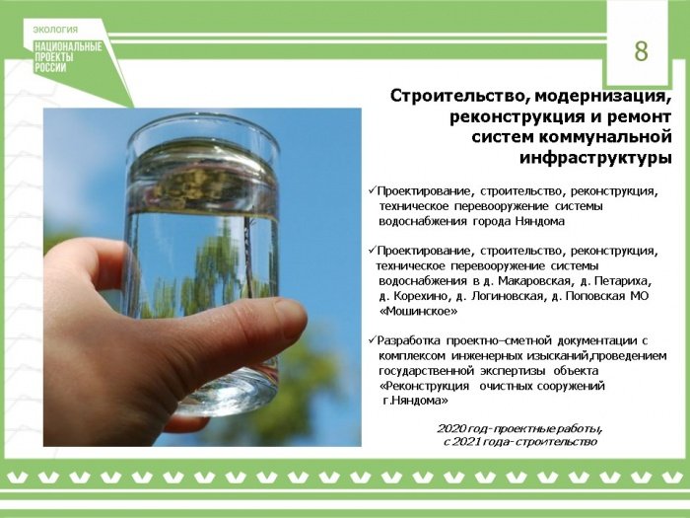](http://nyan-doma.ru/content/site_images/nyan-doma/2020/July/slayd8.jpg)[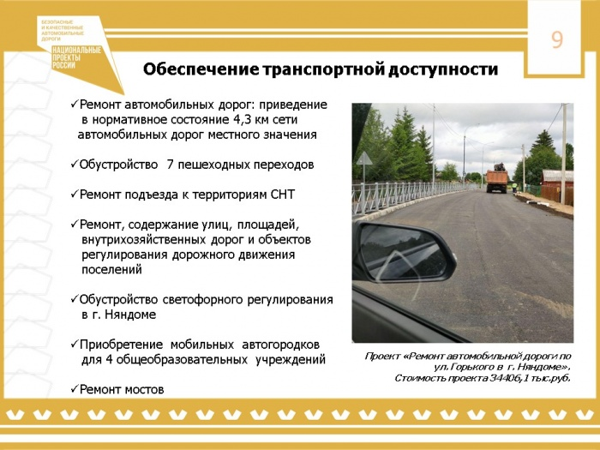](http://nyan-doma.ru/content/site_images/nyan-doma/2020/July/slayd9.jpg)[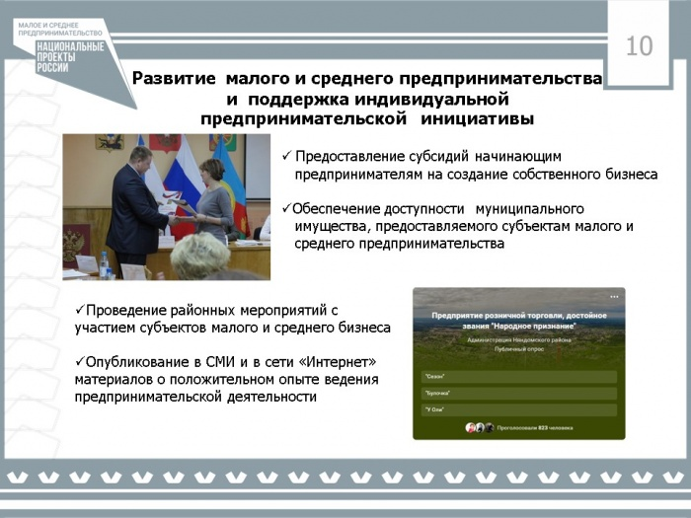](http://nyan-doma.ru/content/site_images/nyan-doma/2020/July/slayd10.jpg)[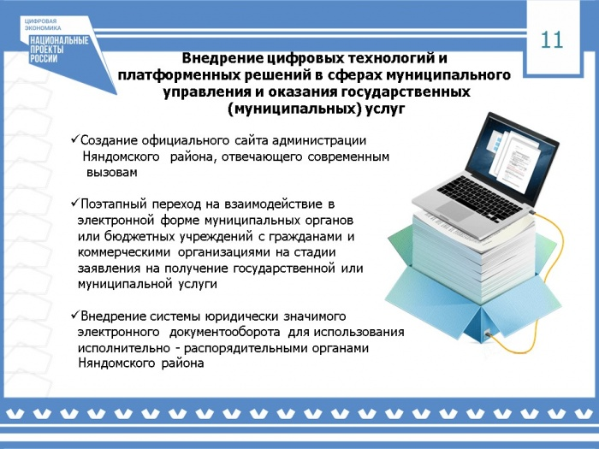](http://nyan-doma.ru/content/site_images/nyan-doma/2020/July/slayd11.jpg)[](http://nyan-doma.ru/content/site_images/nyan-doma/2020/July/slayd12.jpg)